**Practical No 4**

**1)Aim:** Enter an r x c matrix M & display M in matrix format

**Source Code:**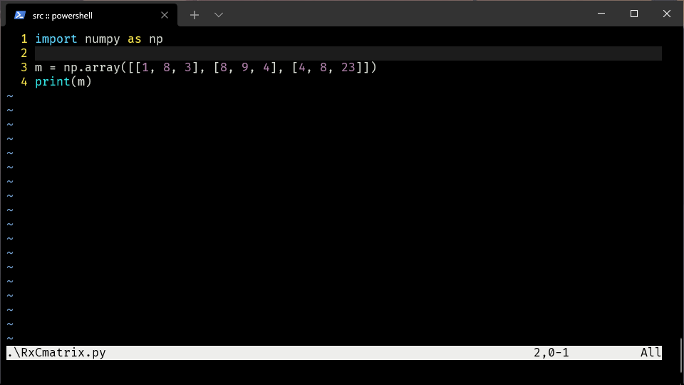

**Output:**

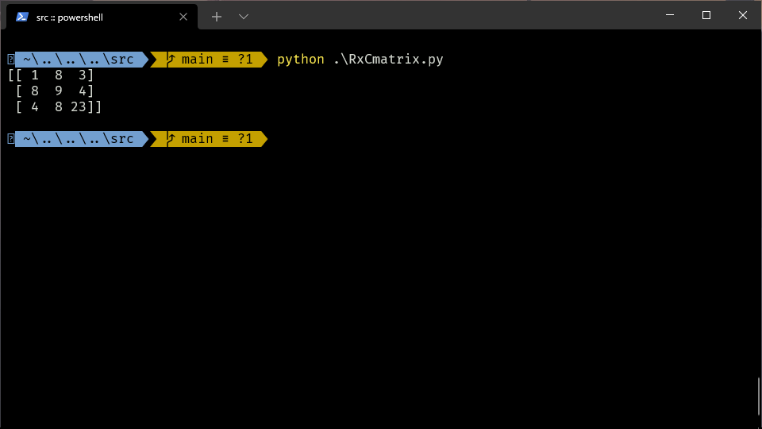

**2)Aim:** Display the rows & columns of the matrix M printing rows &amp; printing

Columns

**Source Code:**

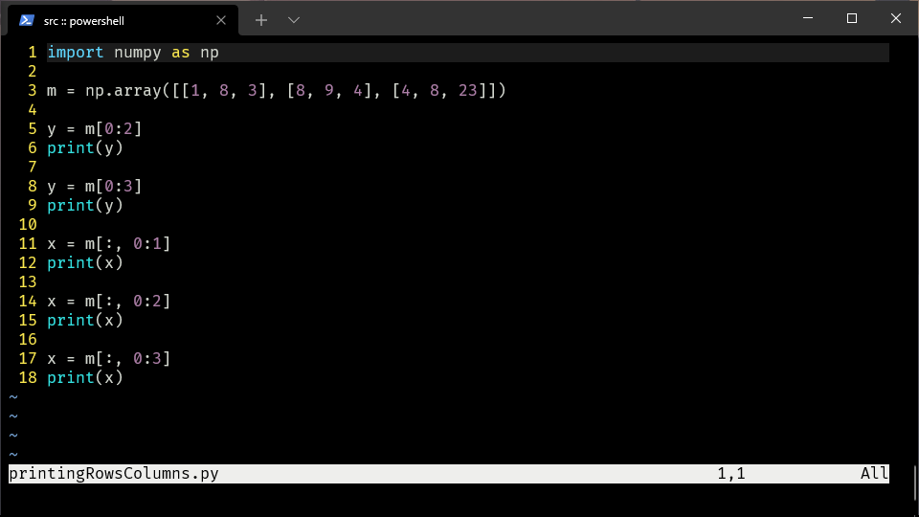

**Output:**

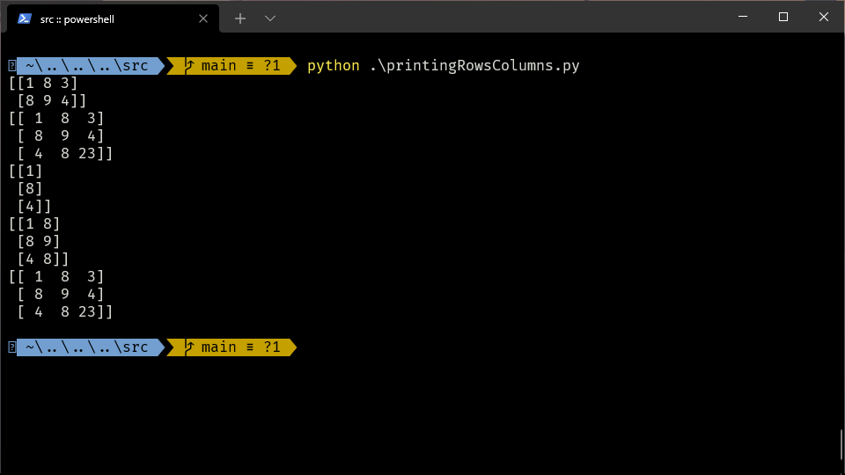

**3)Aim:** Find the scalar multiplication of M for a given scalar

**Source Code:**

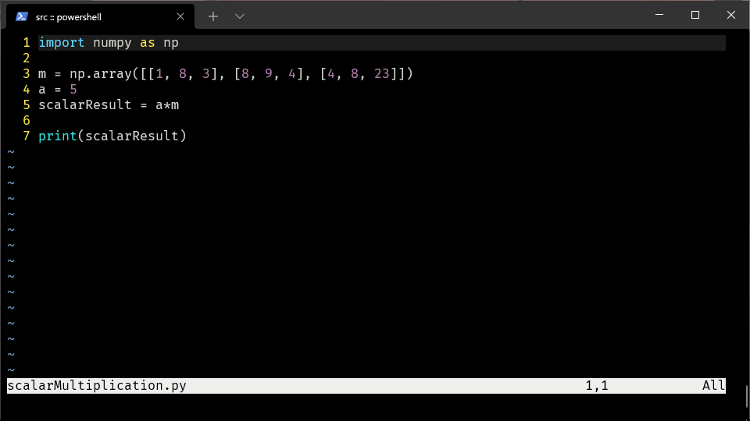

**Output:**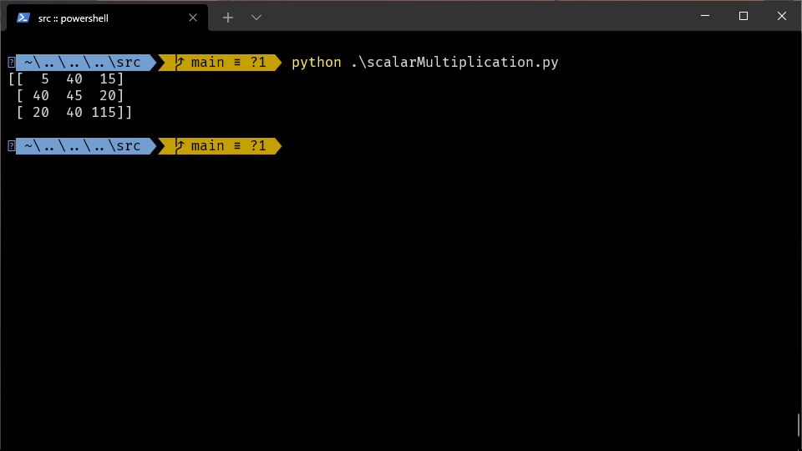

**4)Aim:** Find the transpose of M

**Source Code:**

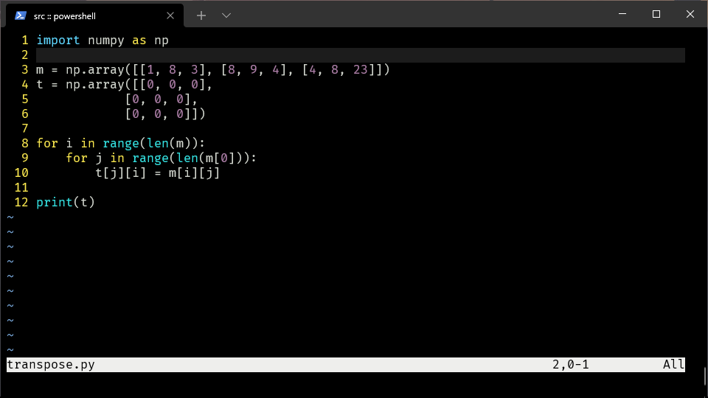

**Output:**

